**CT - LTE TDD data only feature memo**

**Design**

MP can allow AP to change LTE band pref by NAS client,

QMI command: #define QMI_NAS_SET_SYSTEM_SELECTION_PREFERENCE_REQ_MSG_V01 0x0033

MP use 64 bit to store LTE full band pref, the 0~31 bit is for TDD band, the 32~63 bit is for FDD band.

So if want to set TDD only, just clear 32~63 bit will be ok. If want to set FDD only, just clear 0~31 bit.

**API**

Exposed from OemHook.

/**

* FuncName: qcRilSetPreferredNetworkBandPref

*

* Description: Set preferred network band pref.

*

* @param bandPref band pref map

* @param sub subscription ID

*

* @return true Or false

*/

public boolean qcRilSetPreferredNetworkBandPref(int bandPref, int sub)

**bandPref** value pls refer to ENUM qcril_qmi_band_pref_e_type

typedef enum

{

QCRIL_QMI_BAND_PREF_NONE = 0,

QCRIL_QMI_BAND_PREF_LTE_FULL,

QCRIL_QMI_BAND_PREF_TDD_LTE,

QCRIL_QMI_BAND_PREF_FDD_LTE

} qcril_qmi_band_pref_e_type;

**Implementation.**

1. Set LTE full band property in customer build version

persist.radio.lte_full_band 0x7ff5bdf3fff (0x7ff5bd3fff just a reference)

1. Invoke qcRilSetPreferredNetworkBandPref() to set LTE FULL, TDD LTE or FDD LTE
2. Invoke setPreferredNetworkType to set NW to trigger the whole process.

**Sample**

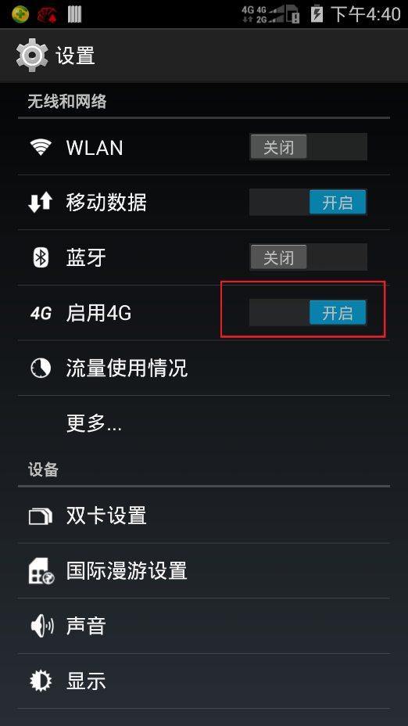

Enable 4G (set NW -> PREF_NET_TYPE_LTE_CMDA_EVDO_GSM_WCDMA )

Disable 4G (set NW -> PREF_NET_TYPE_GSM_WCDMA_CDMA_EVDO_AUTO)

Please refer to RIL_PreferredNetworkType

*typedef enum {*

*PREF_NET_TYPE_GSM_WCDMA = 0, /* GSM/WCDMA (WCDMA preferred) */*

*PREF_NET_TYPE_GSM_ONLY = 1, /* GSM only */*

*PREF_NET_TYPE_WCDMA = 2, /* WCDMA */*

*PREF_NET_TYPE_GSM_WCDMA_AUTO = 3, /* GSM/WCDMA (auto mode, according to PRL) */*

*PREF_NET_TYPE_CDMA_EVDO_AUTO = 4, /* CDMA and EvDo (auto mode, according to PRL) */*

*PREF_NET_TYPE_CDMA_ONLY = 5, /* CDMA only */*

*PREF_NET_TYPE_EVDO_ONLY = 6, /* EvDo only */*

*PREF_NET_TYPE_GSM_WCDMA_CDMA_EVDO_AUTO = 7, /* GSM/WCDMA, CDMA, and EvDo (auto mode, according to PRL) */*

*PREF_NET_TYPE_LTE_CDMA_EVDO = 8, /* LTE, CDMA and EvDo */*

*PREF_NET_TYPE_LTE_GSM_WCDMA = 9, /* LTE, GSM/WCDMA */*

*PREF_NET_TYPE_LTE_CMDA_EVDO_GSM_WCDMA = 10, /* LTE, CDMA, EvDo, GSM/WCDMA */*

*PREF_NET_TYPE_LTE_ONLY = 11, /* LTE only */*

*PREF_NET_TYPE_LTE_WCDMA = 12, /* LTE/WCDMA */*

*PREF_NET_TYPE_TD_SCDMA_ONLY = 13, /* TD-SCDMA only */*

*PREF_NET_TYPE_TD_SCDMA_WCDMA = 14, /* TD-SCDMA and WCDMA */*

*PREF_NET_TYPE_TD_SCDMA_LTE = 15, /* TD-SCDMA and LTE */*

*PREF_NET_TYPE_TD_SCDMA_GSM = 16, /* TD-SCDMA and GSM */*

*PREF_NET_TYPE_TD_SCDMA_GSM_LTE = 17, /* TD-SCDMA,GSM and LTE */*

*PREF_NET_TYPE_TD_SCDMA_GSM_WCDMA = 18, /* TD-SCDMA, GSM/WCDMA */*

*PREF_NET_TYPE_TD_SCDMA_WCDMA_LTE = 19, /* TD-SCDMA, WCDMA and LTE */*

*PREF_NET_TYPE_TD_SCDMA_GSM_WCDMA_LTE = 20, /* TD-SCDMA, GSM/WCDMA and LTE */*

*PREF_NET_TYPE_TD_SCDMA_GSM_WCDMA_CDMA_EVDO_AUTO = 21, /* TD-SCDMA, GSM/WCDMA, CDMA and EvDo */*

*PREF_NET_TYPE_TD_SCDMA_LTE_CDMA_EVDO_GSM_WCDMA = 22 /* TD-SCDMA, LTE, CDMA, EvDo GSM/WCDMA */*

*} RIL_PreferredNetworkType;*

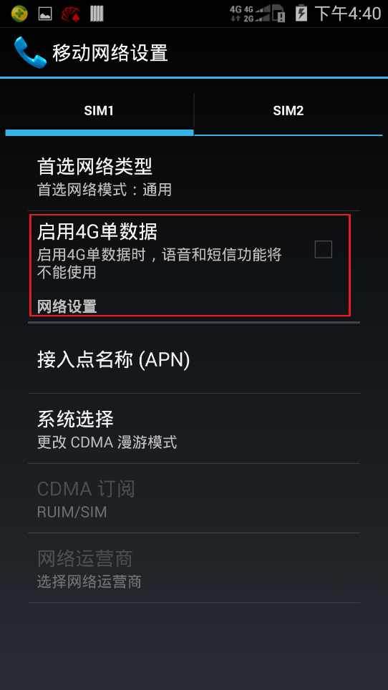

**Enable 4G single data**

**Checked,** set TDD only by qcRilSetPreferredNetworkBandPref(); set NW to LTE only.

**Unchecked,** set FDD only by qcRilSetPreferredNetworkBandPref(); set NW to value cached last time.